**DAILY ONLINE ACTIVITIES SUMMARY**

|  |  |  |  |  |  |  |  |  |
| --- | --- | --- | --- | --- | --- | --- | --- | --- |
| **Date:** | **20/05/2020** | | | | | **Name:** | **NAIPUNYA VINOD NAIK** | |
| **Sem & Sec** | **IV SEM & A SECTION** | | | | | **USN:** | **4AL18CS050** | |
| **Online Test Summary** | | | | | | | | |
| **Subject** | | **OBJECT ORIENTED CONCEPTS** | | | | | | |
| **Max. Marks** | | **30** | | **Score** | | | **20** | |
| **Certification Course Summary** | | | | | | | | |
| **Course** | **INTRODUCTION TO HADOOP** | | | | | | | |
| **Certificate Provider** | | | **GREAT LEARNING ACADEMY** | | **Duration** | | | **5.5 HRS** |
| **Coding Challenges** | | | | | | | | |
| **Problem Statement:** Write a C Program to Reverse a Linked List (SLL) in groups of given size TEST Case 2: If a linked list is: 1 → 2 → 3 → 4 → 5 → 6 → 7 → 8 The value of size k is 3 Then the linked list looks like: 3 → 2 → 1 → 6 → 5 → 4 → 8 → 7  2. Write a C or Java program to implement FCFS and SJF process scheduling. Input: Processes with burst time Output: Process being scheduled | | | | | | | | |
| **Status: COMPLETED** | | | | | | | | |
| **Uploaded the report in Github** | | | | | **YES** | | | |
| **If yes Repository name** | | | | | <https://github.com/naiknaipu/lockdown-coding/blob/master/reverselinkedlisttestcase2.c>  <https://github.com/naiknaipu/lockdown-coding/blob/master/FCFS.c> | | | |
| **Uploaded the report in slack** | | | | | **YES** | | | |

Online Test Details: (Attach the snapshot and briefly write the report for the same)

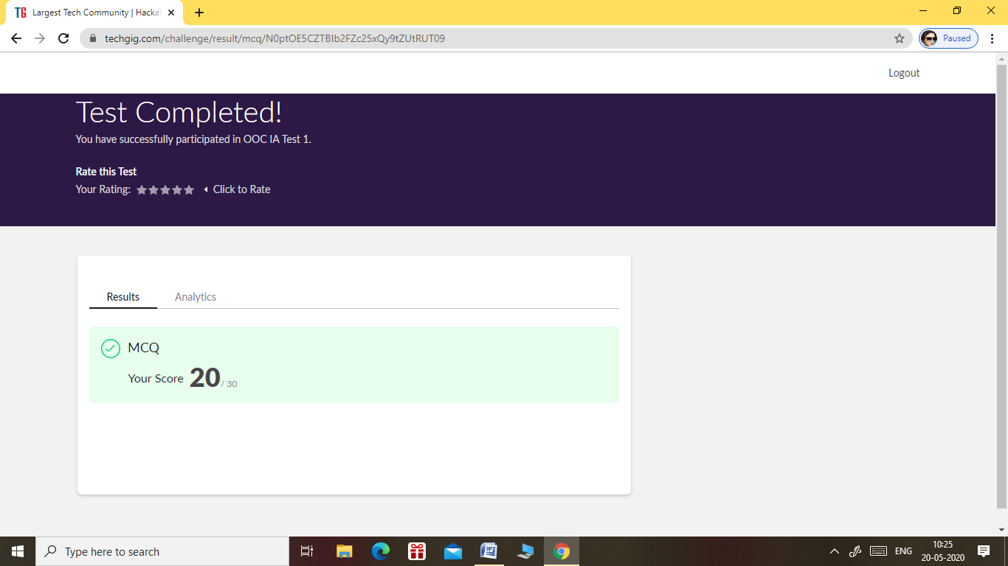

* THE OOC TEST WAS HELD ON 20 MAY 2020 AT 9.30AM TILL 10.10AM
* THE TEST DURATION WAS OF 40 MIN
* THE TOTAL MARKS OF THE 1ST I.A WAS 30 MARKS
* THE TEST COMPRISED OF 30 QUESTIONS OF 1 MARK EACH

Certification Course Details: (Attach the snapshot and briefly write the report for the same)

INTRODUCTION TO HADOOP (DAY 3)

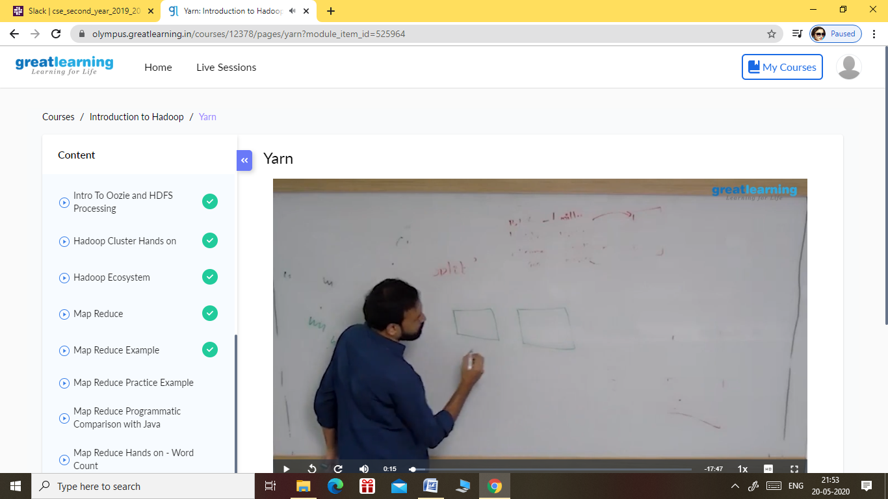

TOPICS COVERED ON 20 MAY 2020:-

* MAP REDUCE PRACTICE EXAMPLE
* MAP REDUCE PROGRAMMATIC COMPARISON WITH JAVA
* MAP REDUCE HANDS-WORD COUNT
* MAP REDUCE WORD COUNT CODE
* YARN

Coding Challenges Details: (Attach the snapshot and briefly write the report for the same)

1ST PROGRAM

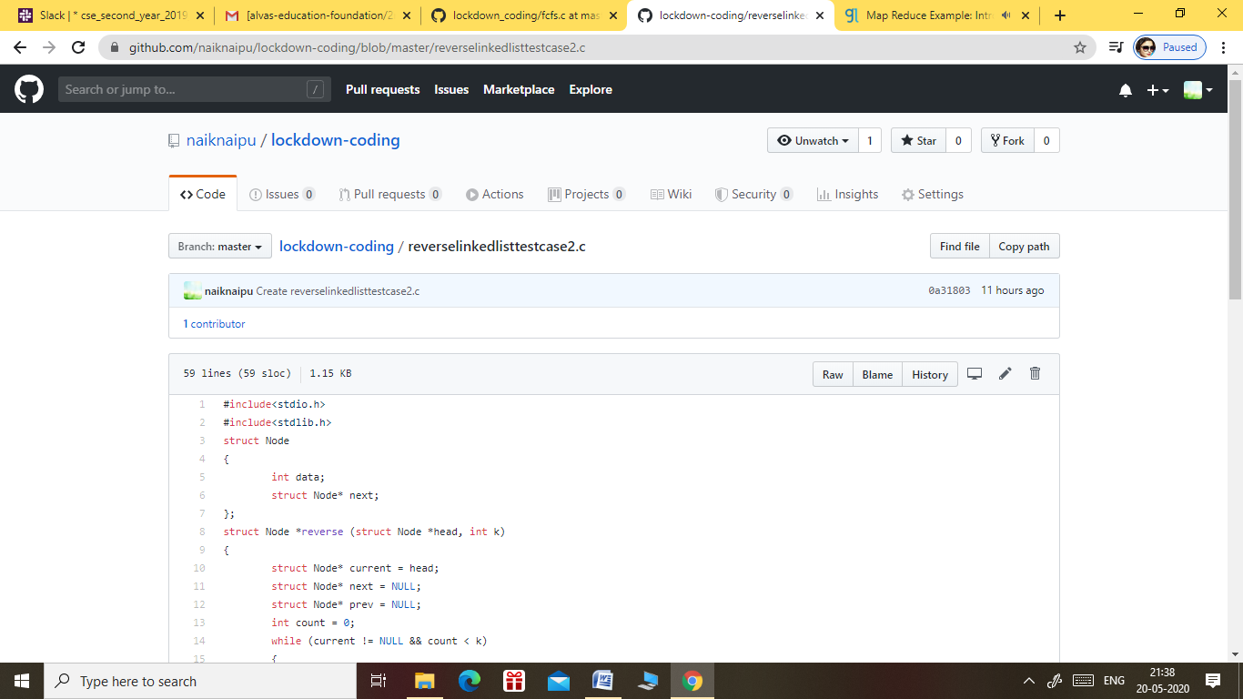

OUTPUT OF THE FOLLOWING PROGRAM:-

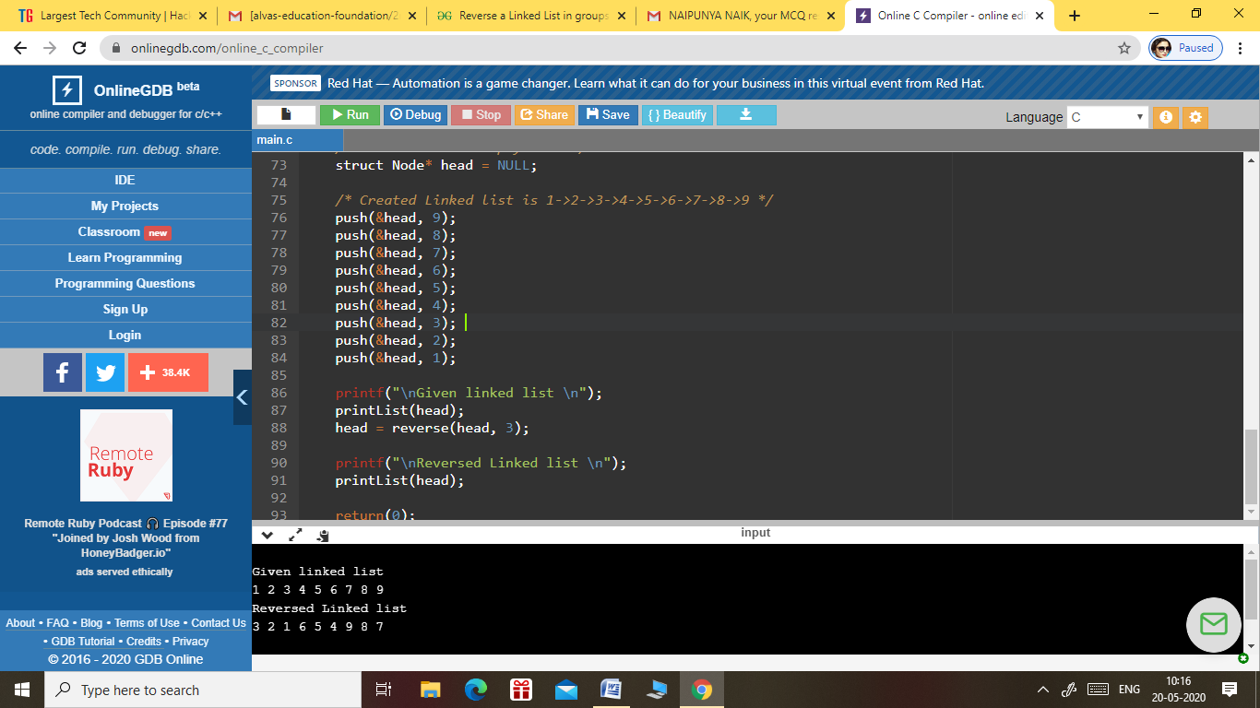

2. PROGRAM

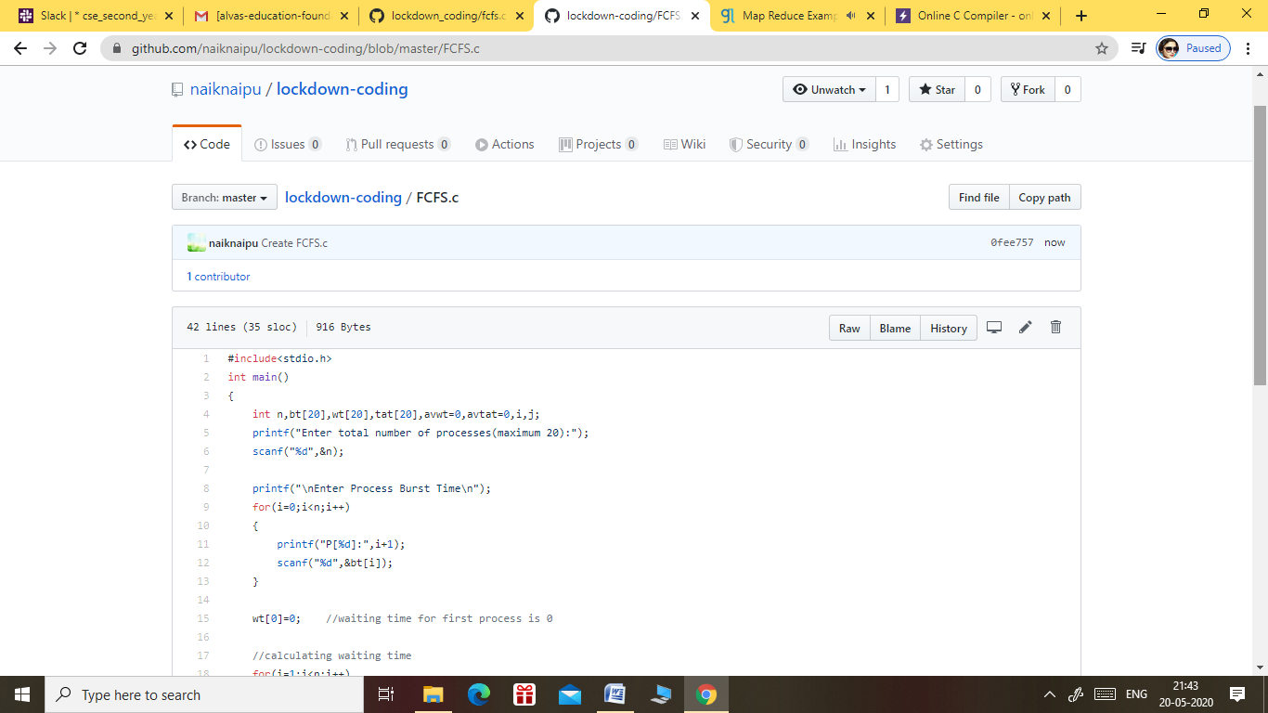

OUTPUT OF THE 2ND PROGRAM:-

